Holy Eucharist Rite II with Baptism

July 20, 2025, 10:30 a.m.  
The Sixth Sunday after Pentecost

**All Saints Church, Chevy Chase Parish**

3 Chevy Chase Circle, Chevy Chase, Maryland 20815

301-654-2488 ~ info@allsaintschurch.net

www.allsaintschurch.net   
  
**Church Office: Tuesday – Thursday 9 a.m. – 5 p.m.; closed 1 - 2 p.m.**

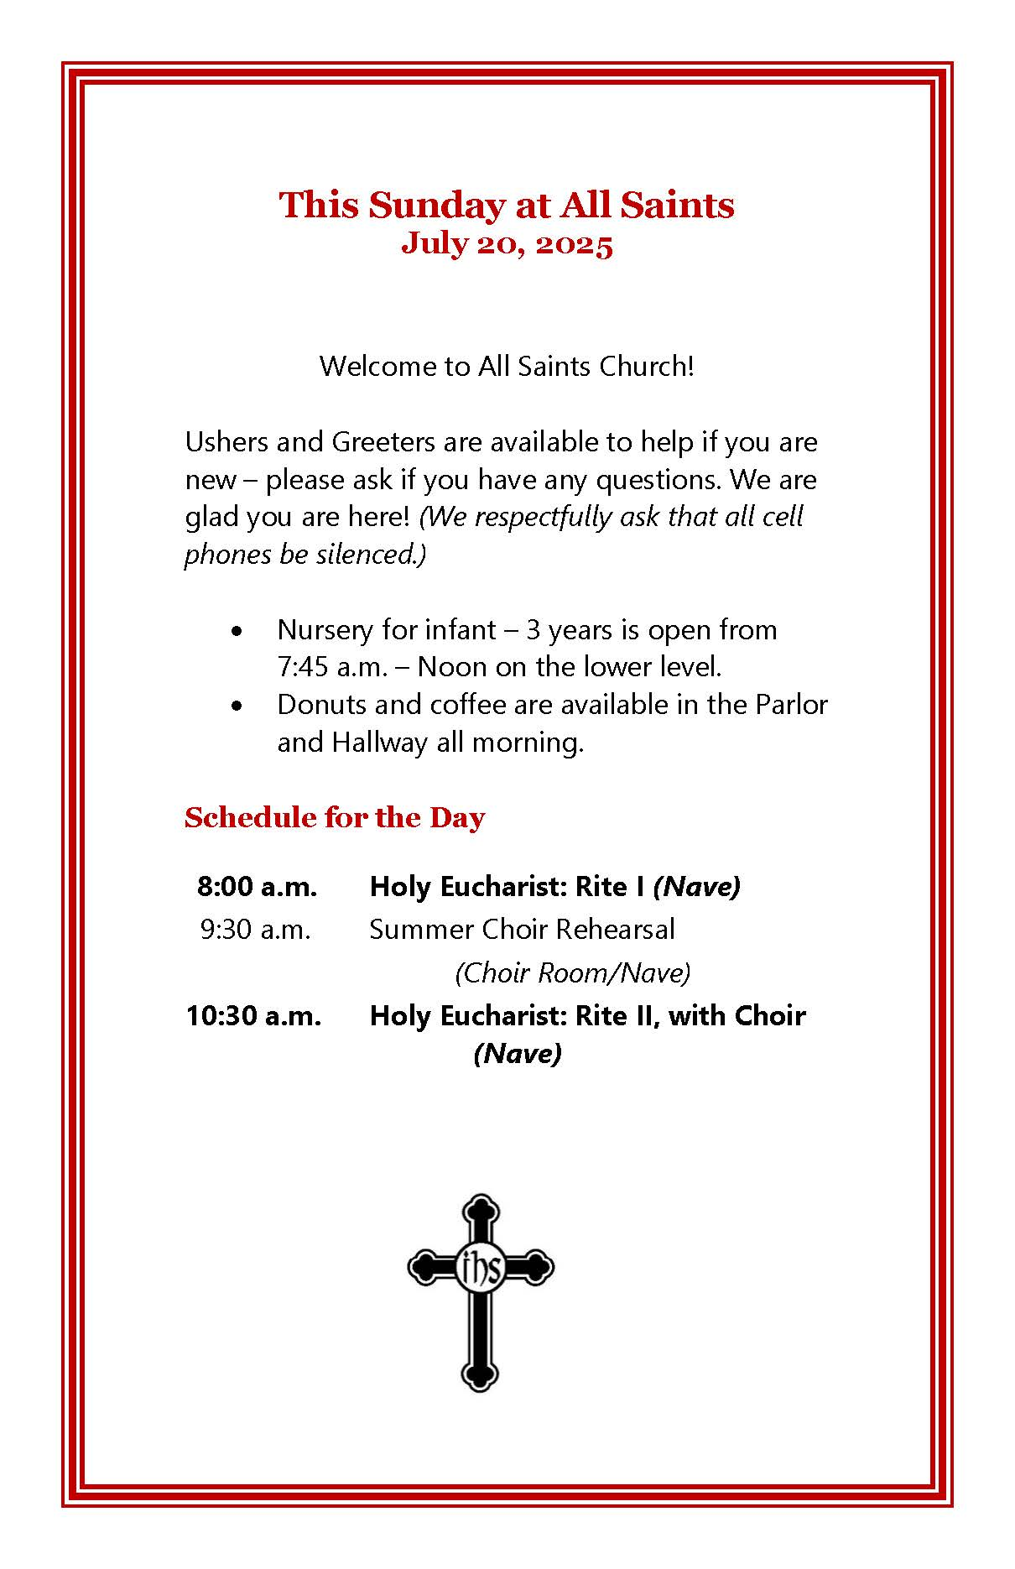

Opening Liturgy

**Prelude**

**Processional Hymn** Hymnal 423 – Immortal, invisible, God only wise

**Opening Sentences**

|  |  |
| --- | --- |
| *Celebrant:* | Blessed be God: Father, Son, and Holy Spirit. |
| ***People:*** | **And blessed be his kingdom, now and for ever. Amen.** |
| *Celebrant:* | There is one Body and one Spirit; |
| ***People:*** | **There is one hope in God's call to us;** |
| *Celebrant:* | One Lord, one Faith, one Baptism; |
| ***People:*** | **One God and Father of all.** |

The Collect of the Day

|  |  |
| --- | --- |
| *Celebrant:* | The Lord be with you. |
| ***People:*** | **And also with you.** |
| *Celebrant:* | Let us pray.  Almighty God, the fountain of all wisdom, you know our necessities before we ask and our ignorance in asking: Have compassion on our weakness, and mercifully give us those things which for our unworthiness we dare not, and for our blindness we cannot ask; through the worthiness of your Son Jesus Christ our Lord, who lives and reigns with you and the Holy Spirit, one God, now and for ever. ***Amen.*** |

The Reading of Scripture  
  
The First Lesson *The congregation may be seated.*

*Colossians 1:15-28*

*Reader:*  A reading from Paul’s Epistle to the Colossians.

Christ Jesus is the image of the invisible God, the firstborn of all creation; for in him all things in heaven and on earth were created, things visible and invisible, whether thrones or dominions or rulers or powers-- all things have been created through him and for him. He himself is before all things, and in him all things hold together. He is the head of the body, the church; he is the beginning, the firstborn from the dead, so that he might come to have first place in everything. For in him all the fullness of God was pleased to dwell, and through him God was pleased to reconcile to himself all things, whether on earth or in heaven, by making peace through the blood of his cross. And you who were once estranged and hostile in mind, doing evil deeds, he has now reconciled in his fleshly body through death, so as to present you holy and blameless and irreproachable before him-- provided that you continue securely established and steadfast in the faith, without shifting from the hope promised by the gospel that you heard, which has been proclaimed to every creature under heaven. I, Paul, became a servant of this gospel. I am now rejoicing in my sufferings for your sake, and in my flesh I am completing what is lacking in Christ's afflictions for the sake of his body, that is, the church. I became its servant according to God's commission that was given to me for you, to make the word of God fully known, the mystery that has been hidden throughout the ages and generations but has now been revealed to his saints. To them God chose to make known how great among the Gentiles are the riches of the glory of this mystery, which is Christ in you, the hope of glory. It is he whom we proclaim, warning everyone and teaching everyone in all wisdom, so that we may present everyone mature in Christ.

*Reader:* The Word of the Lord.

***All:*** **Thanks be to God.**

**Psalm 15** (*Please read responsively, by half verse.)*

1 Lord, who may dwell in your tabernacle? *

**who may abide upon your holy hill?**

2 Whoever leads a blameless life and does what is right, *

**who speaks the truth from his heart.**

3 There is no guile upon his tongue;

he does no evil to his friend; *

**he does not heap contempt upon his neighbor.**

4 In his sight the wicked is rejected, *

**but he honors those who fear the Lord.**

5 He has sworn to do no wrong *

**and does not take back his word.**

6 He does not give his money in hope of gain, *

**nor does he take a bribe against the innocent.**

7 Whoever does these things *

**shall never be overthrown.**

All stand.

**Sequence Hymn** Hymnal 440 – Blessed Jesus, at thy Word

*At this time, Children’ PreK – 2nd grade may follow the cross to be dismissed for Kids’ Time;   
they will return in time to watch the Baptism.*

**The Gospel***Luke 10:38-42**Gospeller:* The Holy Gospel of our Lord Jesus Christ according to Luke.   
***People:* Glory be to thee, O Lord.**

As Jesus and his disciples went on their way, Jesus entered a certain village, where a woman named Martha welcomed him into her home. She had a sister named Mary, who sat at the Lord's feet and listened to what he was saying. But Martha was distracted by her many tasks; so she came to him and asked, "Lord, do you not care that my sister has left me to do all the work by myself? Tell her then to help me." But the Lord answered her, "Martha, Martha, you are worried and distracted by many things; there is need of only one thing. Mary has chosen the better part, which will not be taken away from her."

*Gospeller:* The Gospel of the Lord.  
*People:*  Praise be to thee, Lord Christ.

**Sermon: The Rev. Jamie Pahl**

**Holy Baptism***.***Presentation and Examination of the Candidates***The baptismal candidates and sponsors proceed to the area near the font.*

*Children may come forward to sit on the carpets at the front of the church to observe.*

|  |  |
| --- | --- |
| *Celebrant:* | Beloved in the Lord, we have come together in the presence of Almighty God our heavenly Father to witness the Sacrament of Holy Baptism by which these persons are to be made members of Christ's Body, the Church. By the working of this holy sacrament, ordained by Christ himself, they will die to sin and be raised to newness of life, receiving the fullness of God's grace that they may faithfully serve him all the days of their lives.  The Candidates for Holy Baptism will now be presented. |
| *The candidates are presented individually by their Parents and Godparents, as follows* | |
|  | **I present *N.* to receive the Sacrament of Baptism.** |
| *When all have been presented the Celebrant asks the parents and godparents* | |
| *Celebrant:* | Will you be responsible for seeing that the child you present is brought up in the Christian faith and life? |
| ***Answer:*** | **I will, with God’s help.** |
| *Celebrant:* | Will you by your prayers and witness help this child to grow into the full stature of Christ? |
| ***Answer:*** | **I will, with God’s help.** |
| *Then the Celebrant asks the following questions of the of the parents and godparents who speak on behalf of the infants and younger children* | |
| *Celebrant:* | Do you renounce Satan and all the spiritual forces of wickedness that rebel against God? |
| ***Answer:*** | **I renounce them.** |
| *Celebrant:* | Do you renounce the evil powers of this world which corrupt and destroy the creatures of God? |
| ***Answer:*** | **I renounce them.** |
| *Celebrant:* | Do you renounce all sinful desires that draw you from the love of God? |
| ***Answer:*** | **I renounce them.** |
| *Celebrant:* | Do you turn to Jesus Christ and accept him as your Savior? |
| ***Answer****:* | **I do.** |
| *Celebrant:* | Do you put your whole trust in his grace and love? |
| ***Answer:*** | **I do.** |
| *Celebrant:* | Do you promise to follow and obey him as your Lord? |
| ***Answer:*** | **I do.** |
| *Then the Celebrant addresses the congregation, asking:* | |
| *Celebrant:* | Will you who witness these vows do all in your power to support these persons in their life in Christ? |
| ***People:*** | **We will.** |

**The Baptismal Covenant**

|  |  |
| --- | --- |
| *Celebrant:* | Let us now join with those who are committing themselves to Christ and renew our own Baptismal Covenant. |
|  | Do you believe in God the Father? |
| ***People:*** | **I believe in God, the Father Almighty, creator of heaven and earth.** |
| *Celebrant:* | Do you believe in Jesus Christ, the Son of God? |
| ***People:*** | **I believe in Jesus Christ, his only Son, our Lord.   He was conceived by the power of the Holy Spirit   and born of the Virgin Mary.**  **He suffered under Pontius Pilate,   was crucified, died, and was buried.  He descended to the dead.  On the third day he rose again.  He ascended into heaven,   and is seated at the right hand of the Father.  He will come again to judge the living and the dead.** |
| *Celebrant:* | Do you believe in God the Holy Spirit? |
| ***People:*** | **I believe in the Holy Spirit,   the holy Catholic Church,   the communion of saints,   the forgiveness of sins,   the resurrection of the body,   and the life everlasting.** |
| *Celebrant:* | Will you continue in the apostles’ teaching and fellowship,  in the breaking of bread, and in the prayers? |
| ***People:*** | **I will, with God’s help.** |
| *Celebrant:* | Will you persevere in resisting evil, and, whenever you fall into sin, repent and return to the Lord? |
| ***People:*** | **I will, with God’s help.** |
| *Celebrant:* | Will you proclaim by word and example the Good News of God in Christ? |
| ***People:*** | **I will, with God’s help.** |
| *Celebrant:* | Will you seek and serve Christ in all persons, loving your neighbor as yourself? |
| ***People:*** | **I will, with God’s help.** |
| *Celebrant:* | Will you strive for justice and peace among all people, and respect the dignity of every human being? |
| ***People:*** | **I will, with God’s help.** |

**Prayers for the Candidates**

*(Congregation may be seated.)*

|  |  |
| --- | --- |
| *Celebrant:* | Let us now pray for these persons who are to receive the Sacrament of new birth.  Deliver them, O Lord, from the way of sin and death. |
| ***People:*** | **Lord, hear our prayer.** |
| *Celebrant:* | Open their hearts to your grace and truth. |
| ***People:*** | **Lord, hear our prayer.** |
| *Celebrant:* | Fill them with your holy and life-giving Spirit. |
| ***People:*** | **Lord, hear our prayer.** |
| *Celebrant:* | Keep them in the faith and communion of your holy Church. |
| ***People:*** | **Lord, hear our prayer.** |
| *Celebrant:* | Teach them to love others in the power of the Spirit. |
| ***People:*** | **Lord, hear our prayer.** |
| *Celebrant:* | Send them into the world in witness to your love. |
| ***People****:* | **Lord, hear our prayer.** |
| *Celebrant:* | Bring them to the fullness of your peace and glory. |
| ***People:*** | **Lord, hear our prayer.** |
| *Celebrant:* | Grant, O Lord, that all who are baptized into the death of Jesus Christ your Son may live in the power of his resurrection and look for him to come again in glory; who lives and reigns now and forever. |
| ***People:*** | **Amen.** |

**The Thanksgiving over the Water**

|  |  |
| --- | --- |
| *Celebrant:* | The Lord be with you. |
| ***People:*** | **And also with you.** |
| *Celebrant:* | Let us give thanks to the Lord our God. |
| ***People:*** | **It is right to give him thanks and praise.** |
| *Celebrant:* | We thank you, Almighty God, for the gift of water. Over it the Holy Spirit moved in the beginning of creation. Through it you led the children of Israel out of their bondage in Egypt into the land of promise. In it your Son Jesus received the baptism of John and was anointed by the Holy Spirit as the Messiah, the Christ, to lead us, through his death and resurrection, from the bondage of sin into ever-lasting life.  We thank you, Father for the water of Baptism. In it we are buried with Christ in his death. By it we share in his resurrection. Through it we are reborn by the Holy Spirit. Therefore in joyful obedience to your Son,  we bring into his fellowship those who come to him in faith, baptizing them in the Name of the Father, and of the Son, and of the Holy Spirit. |
|  | |
|  | Now sanctify this water, we pray you, by the power of your Holy Spirit, that those who here are cleansed from sin and born again may continue for ever in the risen life of Jesus Christ our Savior. To him, to you, and to the Holy Spirit, be all honor and glory, now and for ever. |
| ***All:*** | **Amen.** |

**The Baptisms**

*Each candidate is presented by first name.*

|  |  |
| --- | --- |
| *Celebrant:* | Name this child. |
|  | |
| *Celebrant:* | *N.,* I baptize you in the Name of the Father, and of the Son,  and of the Holy Spirit. |
| ***People:*** | **Amen.** |

|  |  |
| --- | --- |
| *The candidate is marked on the forehead with holy oil in the sign of the cross.* | |
| *Celebrant:* | *N.*, you are sealed by the Holy Spirit in Baptism and marked as Christ’s own for ever. |
| ***People:*** | **Amen.** |

|  |  |
| --- | --- |
| *A Baptismal Candle is lighted from the Paschal Candle and presented, the Celebrant saying,* | |
| *Celebrant:* | Receive the light of Christ. |
| *When this action has been completed for all candidates, the Celebrant prays over the newly baptized:* | | |
| *Celebrant:* | Let us pray.  Heavenly Father, we thank you that by water and the Holy Spirit you have bestowed upon these your servants the forgiveness of sin, and have raised them to the new life of grace. Sustain them, O Lord, in your Holy Spirit. Give them an inquiring and discerning heart, the courage to will and to persevere, a spirit to know and to love you, and the gift of joy and wonder in all your works. | |
| ***People:*** | **Amen.** | |
| *Celebrant:* | Let us welcome the newly baptized. | |
| ***People:*** | **We receive you into the household of God. Confess the faith of Christ crucified, proclaim his resurrection, and share with us in his eternal priesthood.** | |

**The Peace** All stand.

|  |  |
| --- | --- |
| *Celebrant:* | The peace of the Lord be always with you. |
| ***People:*** | **And also with you.** |

*All exchange a sign of peace.*

**Announcements**  
Offerings may be made by placing cash or check in offering plate, or you may give online at: *allsaintschurch.net/give.*

**Offertory Anthem** This is the hour of banquet and of song –

Richard Shephard

(Copyright © 1997 St. James Music Press. Permission to livestream granted under User ID 2186.)

*(Sung by the All Saints Summer Choir)*

**Welcome & Offering**  
Offerings may be made by placing cash or check in offering plate, using this QR code, or online at: *allsaintschurch.net/give.*

**Presentation Hymn** Hymnal 380, v. 3 *(Please stand. All may join in singing.)*

*Praise God, from whom all blessings flow;*

*Praise him, all creatures here below;*

*Praise him above, ye heavenly host:*

*Praise Father, Son, and Holy Ghost.*

**The Great Thanksgiving Eucharistic Prayer A** *Our service continues on* ***page 361*** *in the Book of Common Prayer (BCP), the red book in the pews.*

**Sanctus et Benedictus**  *Sung to “Land of Rest”*  
 *(“Land of Rest,” arr. Richard Proulx. Copyright © 1986 GIA Publications, Inc. All rights reserved.)*

(*All join in singing)*

*Holy, holy, holy Lord, God of power and might,*

*heaven and earth are full of your glory.*

*Hosanna in the highest.*

*Blessed is he who comes in the name of the Lord.*

*Hosanna in the highest, hosanna in the highest.*

*After the Benedictus, please sit or kneel as able.   
The Celebrant continues on* ***BCP p. 362 & 363*** *until:*

**The Lord’s Prayer *(BCP p. 364)***

**The Breaking of the Bread**  Hymnal S-152

|  |  |
| --- | --- |
| *Cantor:* ***All:*** | Alleluia. Christ our Passover is sacrificed for us; |

*All Saints Church welcomes all baptized Christians to receive the Body and Blood of Christ. If you do not wish to receive Communion at this time, please cross your arms on your chest to receive a blessing. If you have limited mobility, please contact an usher to receive Communion in your seat.*

**Communion Music** Feed Us, Lord – Hal H. Hopson

(*The congregation is encouraged to join with the choir in singing this refrain.)*

**Prayer of Thanksgiving**

**The Blessing** Please stand

**Recessional Hymn** Hymnal 344 – Lord, dismiss us with thy blessing  
*(All may join in singing.)*

**The Dismissal** *Celebrant:* Let us go forth in the name of Christ.***People:* Thanks be to God.**

**Postlude**

*Permission to podcast / stream the music in this service   
obtained from ONE LICENSE,   
License # M-400881.*

**Calendar of Selected Events**

**This Week at a Glance (July 21 – 26)**

***Thrift Shop open Wednesday - Friday, 10:30 a.m. – 1:30 p.m. - 50% SALE all month!***

**Student Ministry Summer Camp** at Ligonier, PA, July 20 - 24

**Monday** *(Church office/reception closed during summer)*

**Tuesday**

7:30 a.m. Morning Prayer *(Zoom)*

**Wednesday**

10:30 a.m. Women’s Bible Study (Library)

5:30 p.m. Prayer Meeting *(Library & Zoom)*

6:00 p.m. All Parish Bible Study – Wisdom Literature *(Library & Zoom)*

**Thursday**

7:30 a.m. Morning Prayer *(Zoom)*

**Friday** *(Church office/reception closed)*

**Saturday**

10:00 a.m. Community Shred Event & Canned Food Drive

**Upcoming Events**

(Full calendar at *allsaintschurch.net* or via weekly Friday parish email)

**School Supplies for Neighbors,** July 27 – August 10

**Nourishing Bethesda Vegetable Harvesting,** August 9

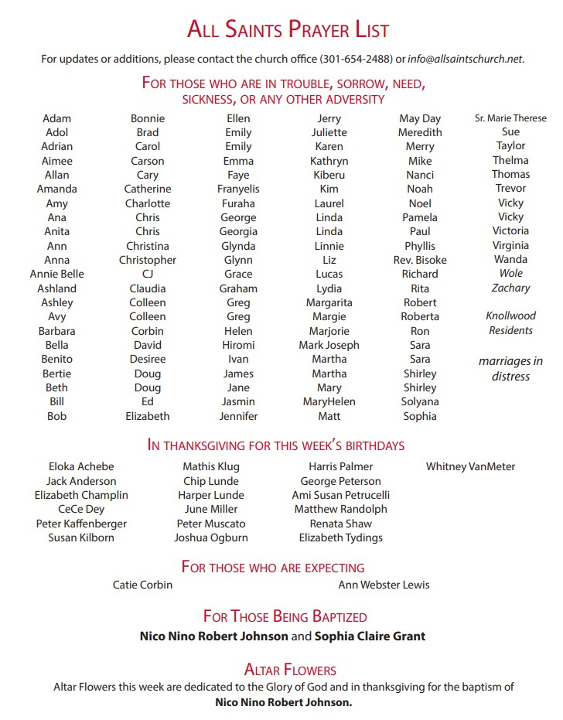

The Rev. Dr. James L. Pahl, Jr, Rector  
The Rev. Dr. William Joseph Buracker II, Vicar

Jeremy Adams, Seminarian  
Gary Wieder, Family Pastor